**Spring Security**

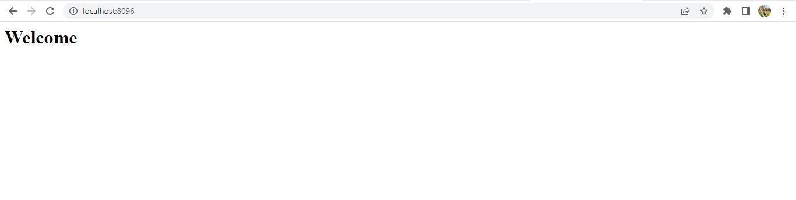

* Local host with port number is run o browser
* Above is the home page, where welcome message is displayed.

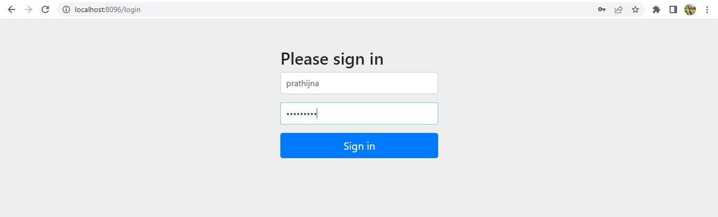

* This is the login page where user name and password is entered, which is statistically set in the code as prathijna and prathijna.
* If the entered details are correct, then user will be landed in user dashboard.

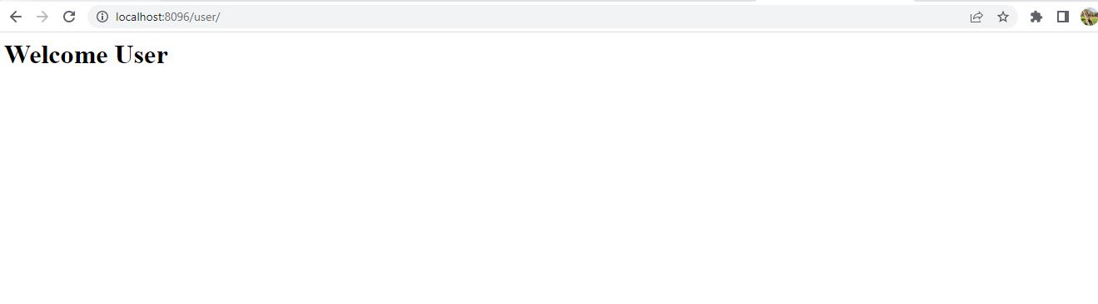

* Above is the user dashboard where welcome home message is displayed.
* Whenever details are entered correctly, only then this page is allowed.

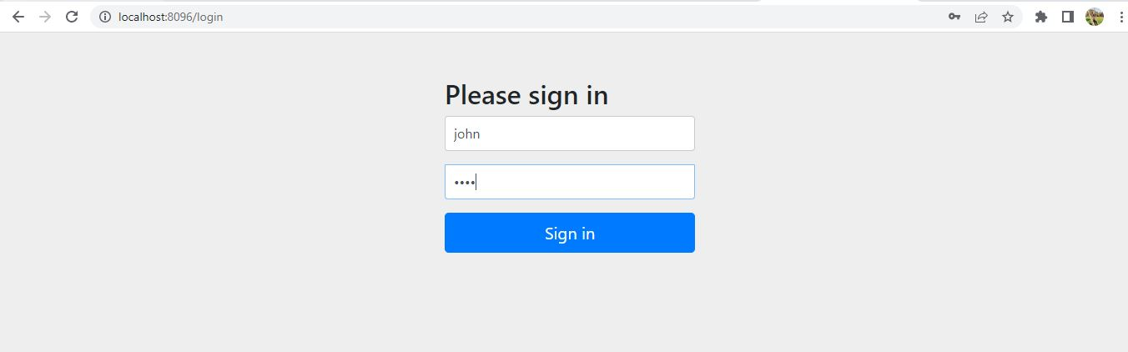

* Here admin login page is visible, details are statistically set in the code.
* Both username and password is john.
* If the details are correct, only then admin will be landed in admin dashboard.

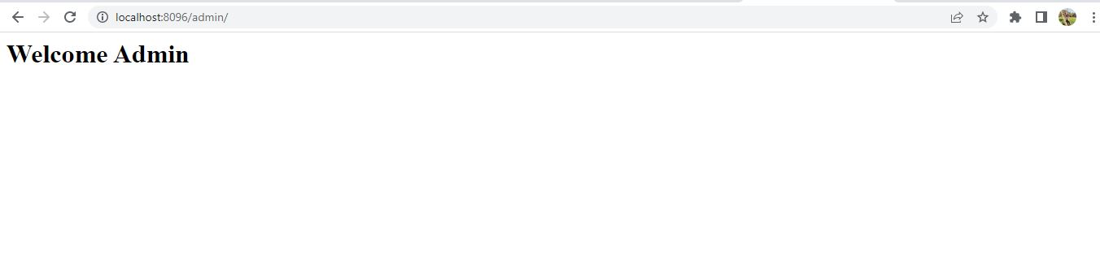

* When user enters correct credentials, then above admin page will be visible.